Meeting Point: 5.00pm-6.30pm

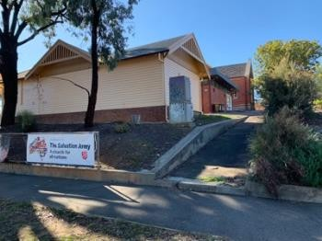

The Salvation Army “Hilltop Café” 65-71 Mundy St, Bendigo

Enter last driveway (closest to trainline and park behind the Church). Bus drivers park bus under Church Carport close to left of driveway.

https://goo.gl/maps/thvm1WhEyTBFGFM17
Weatherboard Shelter Shed from Mundy Street (above). Brick building behind Shelter Shed is Hilltop Café where meeting point is held.

First door of Shelter Shed (closest to Church) is where key to Café and Shelter Shed is kept in key safe behind screen door (see pictures below). To open, flip the cover down, move numbers around to code 1066 and squeeze the buttons on either side of key safe until it opens. Once the key lock is opened, you will need to use one of the keys to open the door to Shelter Shed.

Enter the Shelter Shed and open the 2nd blue door to storage room on your right-hand side. Open this door and on your left get tub with green lid from top of the filing cabinet. Tub contains all the things you will need for Meeting Point including green folder with volunteers and guest sign in sheets. Tea, coffee, sugar, hot chocolate and some games/puzzles for guests. Take this tub with you and open up the Café (alarm is normally turned off).

Any issues with Café of Shelter Shed please call Captain Ashir Morris
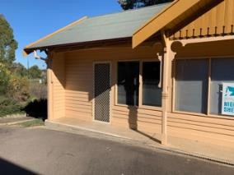
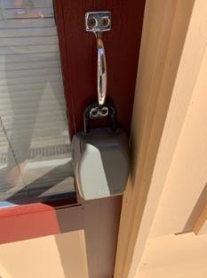
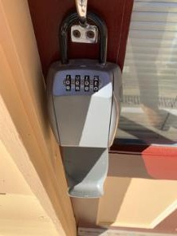

0408 746 144.

Evening Shift 5.30-10.30pm

Koolamurt Scout Camp, 44 Mandurang Rd, Spring Gully.

Volunteers enter main entrance parking in car park on left and exit separate driveway. Bus drivers enter same entrance and exit different driveway on Bendigo side of camp.

https://goo.gl/maps/Qv4nGW8uxQFNaThq7
The key is kept in the key safe on the door to the Koolamurt Recreation Hall/Storage area at the top of the camp on the left-hand side (see photo).

To open, flip the cover down, move numbers around to the code 1951 and squeeze the buttons on either side of key safe until it opens. The key is a red tabbed master key that opens the hall, dorm rooms, cabins, toilets and storage areas and cage that houses washing machine and dryer at Koolamurt.

To access spare bedding from the Recreation Hall storage area get the separate key from the very back of the cutlery (knives and forks) drawer in kitchen. The large yellow key on wooden key ring opens this door. A yellow tabbed spare master key is also in the drawer and can be used for unlocking the laundry cage lock or cabins etc.


